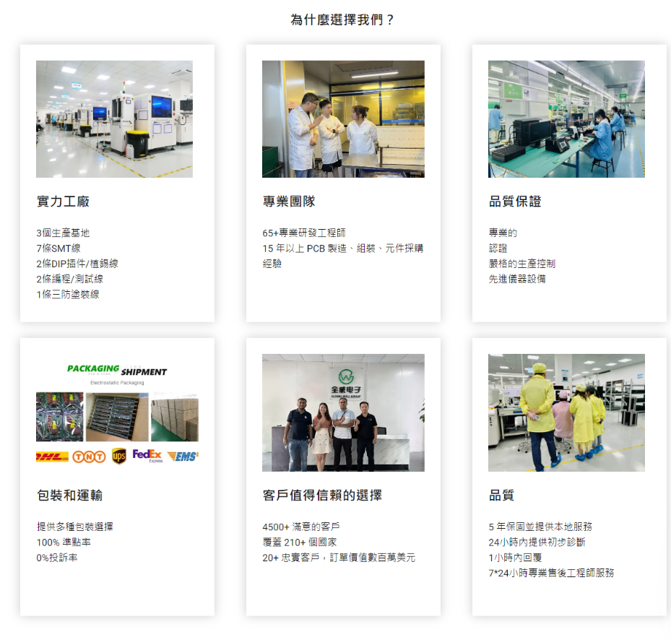

为什么选择我们？（Why Choose Us?）

1. 实力工厂 | Factory Strength
- 2 个生产基地，1000㎡以上无尘生产车间
- 8 条全自动 SMT 贴片线
- 3 条 DIP 插件 / 波峰焊线
- 2 条全自动编程 / 测试线
- 1 条三防涂覆 / 组装线

2. 专业团队 | Professional Team
- 50 + 专业研发与工艺工程师
- 18 年以上 PCB 制造、组装与元件采购经验
- 一对一技术支持与全程项目对接
- 熟悉 IPC、RoHS 等国际标准与行业规范

3. 品质保证 | Quality Assurance
- ISO9001 质量管理体系认证
- 全流程严格生产控制与追溯体系
- 先进 AOI、X-Ray、ICT、FCT 检测设备
- 100% 首件确认 + 全检 / 抽检双重质量把关

4. 包装和运输 | Packaging & Shipment
- 防静电真空包装、防潮 / 防震定制包装方案
- 专业防损包装设计，大幅降低运输风险
- 支持 DHL/UPS/FedEx/ 空运 / 海运等多种物流方式
- 全程物流跟踪与清关协助

5. 客户值得信赖的选择 | Trusted by Clients Worldwide
- 服务全球 3000 + 客户
- 业务覆盖 60 + 国家和地区
- 长期合作客户占比 85% 以上
- 百万美元级稳定订单交付经验

6. 售后保障 | After-sales Service
- 24 小时内提供初步技术诊断
- 1 小时内响应客户咨询
- 7×24 小时专业售后工程师支持
- 产品质保服务，支持返工与返修解决方案

英文版本（适配外贸官网）

Why Choose Us?
1. Factory Strength
- 2 production bases with over 1,000㎡ dust-free workshops
- 8 automatic SMT lines
- 3 DIP / wave soldering lines
- 2 automatic programming & testing lines
- 1 conformal coating & assembly line
2. Professional Team
- 50+ experienced R&D and process engineers
- Over 18 years of experience in PCB manufacturing, assembly and component sourcing
- One-on-one technical support and dedicated project management
- Deep knowledge of international standards such as IPC and RoHS
3. Quality Assurance
- ISO 9001 quality management system certified
- Strict production control and traceability throughout the process
- Advanced AOI, X-Ray, ICT and FCT testing equipment
- 100% first article inspection + full/random dual quality control
4. Packaging & Shipment
- Custom ESD vacuum, moisture-proof and shock-proof packaging solutions
- Professional anti-damage packaging design to minimize transit risks
- Multiple shipping options: DHL/UPS/FedEx/air/sea freight
- Full logistics tracking and customs clearance support
5. Trusted by Clients Worldwide
- Serving 3,000+ customers globally
- Business coverage in 60+ countries and regions
- Over 85% long-term repeat clients
- Proven experience in handling million-dollar order volumes
6. After-sales Service
- Initial technical diagnosis within 24 hours
- Response to inquiries within 1 hour
- 7×24 support from professional after-sales engineers
- Product warranty with rework and repair solutions

