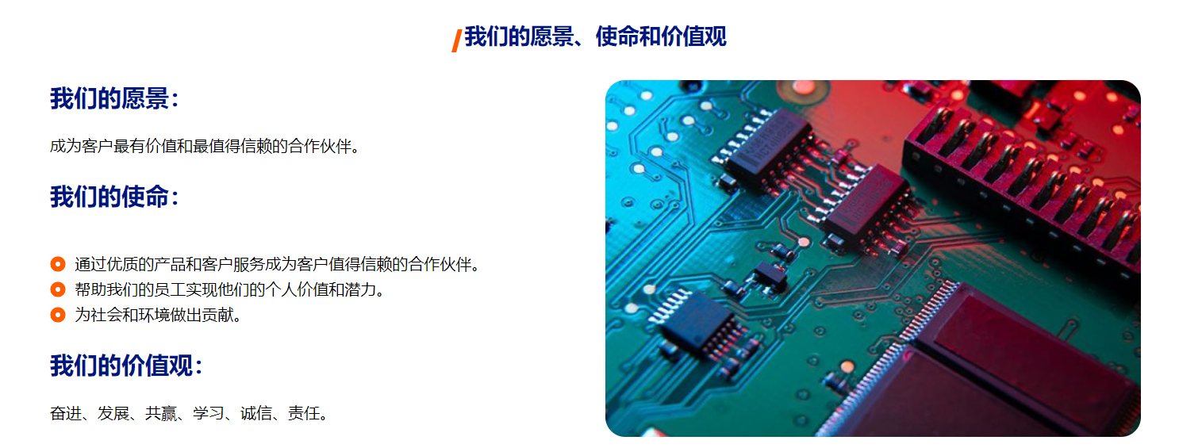
Our Vision: To become the most trusted and valued one-stop PCBA manufacturing and supply chain partner for global electronic enterprises.

Our Mission:
- To deliver cost-effective PCBA and electronic manufacturing solutions with consistent quality, transparent delivery and professional technical support;
- To continuously optimize supply chain efficiency, helping clients reduce costs, shorten lead times and respond to market changes;
- To empower team growth and achieve long-term win-win with employees, customers and partners;
- To practice green manufacturing and contribute to the sustainable development of the industry.

Our Core Values:
- Integrity First: We uphold our commitment to 100% genuine components and full transparency throughout cooperation.
- Quality Focus: We control every process to international standards, ensuring the reliability of every PCBA assembly.
- Customer Centricity: We respond quickly to needs and proactively solve problems, acting as your reliable problem-solver.
- Continuous Improvement: We keep optimizing processes and management to enhance delivery capability and service experience.
- Responsibility: We take responsibility to our customers, employees and society, building an enterprise with long-term value.

